SEDL 7410
Repeat the following test cases for
- An express order. i.e send a IOC order and verify this cases.
- Send an DR order. i.e set the Routing property for a class to be DR-Site enabled.
TestCase1:

Set up the PDPM property by both the option and strategy Class Key .
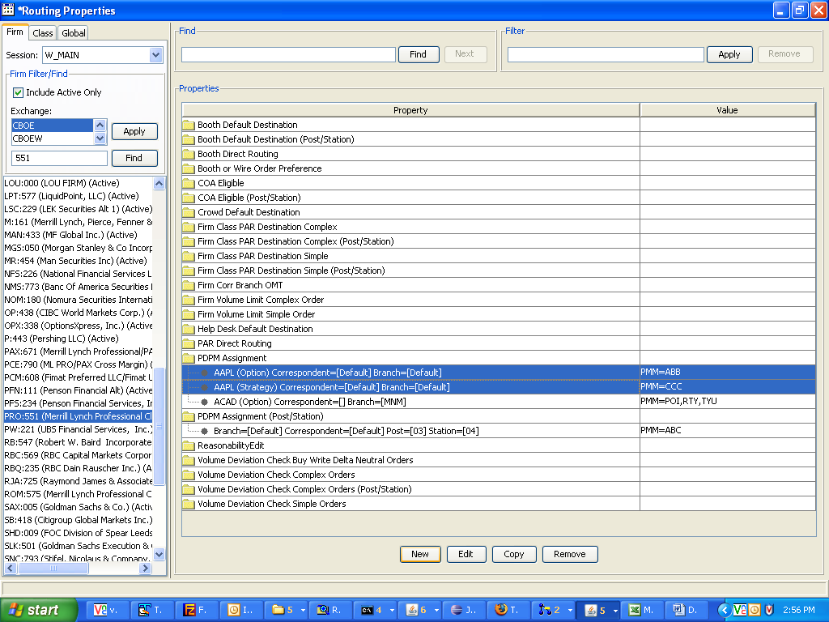
In this example, the property value by option class = ABB and by Strategy class is CCC.

Now route a Complex order from the trader GUI to trade server. Make sure that the firm volume limit, Volume Deviation and COA routing properties are set right.

Note down the branch and branchsequencenumber of this order.

Go to that particular BC where the class belongs to.
(For example: telnet atgqabc64, userid:atgtest6, password:atgtest6)
After logging in, you will be at the run_dir.
Type: loginDb W_MAIN
You will be at the sql prompt
Type:
select extensions from sbtorder where branch='BB' and branchsequencenumber=5;

You should see the PDPM value of the option key property that you had set (i.e. ABB)
You should NOT see the PDPM value of the strategy product (i.e CCC)

TestCase2:
Set up the PDPM property by post and station (in this example it is set to ABC). Remove the PDPM property by option class key.
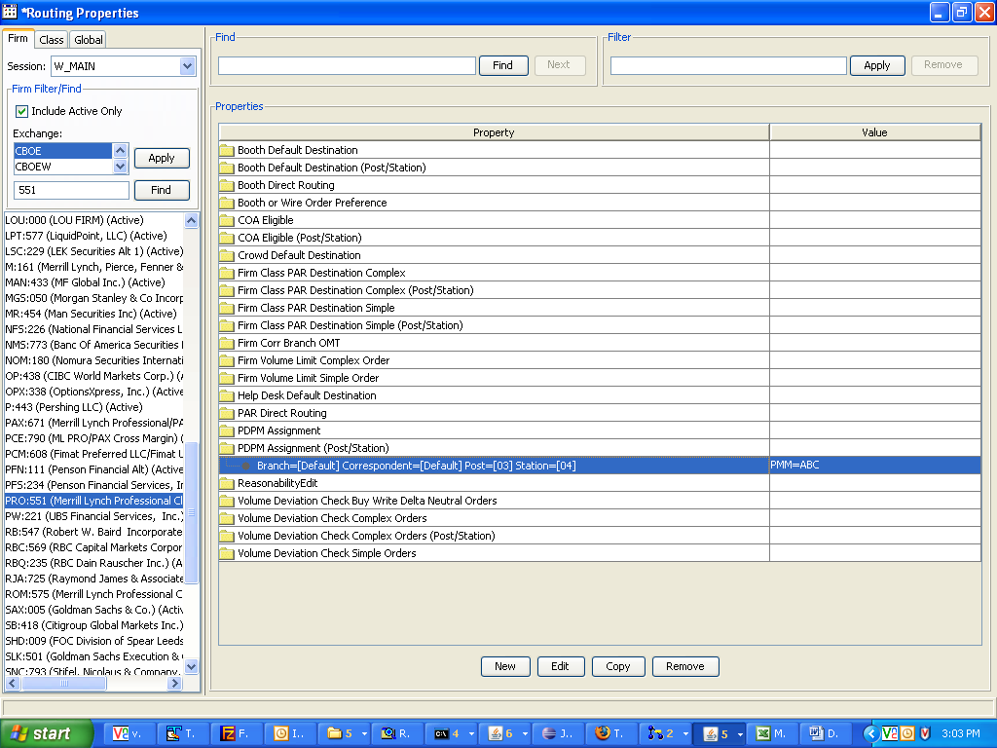
Now route a complex order from the trader GUI to trade server. Make sure that the firm volume limit, Volume Deviation and COA routing properties are set right.

Note down the branch and branchsequencenumber of this order.

Go to that particular BC where the class belongs to.
(For example: telnet atgqabc64, userid:atgtest6, password:atgtest6)
After logging in, you will be at the run_dir.
Type: loginDb W_MAIN
You will be at the sql prompt
Type:
select extensions from sbtorder where branch='BB' and branchsequencenumber=5;

You should see the PDPM value of the option key property that you had set (i.e. ABC)
You should NOT see the PDPM value of the strategy product (i.e CCC)

TestCase3:
Change the PDPM property by post and station to ABD.
Route an order and then run the sql query. You should see ABD as the value.

PITS#11982

Test Case 1
- Setup Booth OMT for a class and a firm
- Log in the Trader GUI as a Market Maker AA, create a CAB order with Buy side and direct route the order to the Booth OMT.
- Login the second Trader GUI as a Market Maker BB, create a CAB order with Sell side and direct route the order to the Booth OMT.

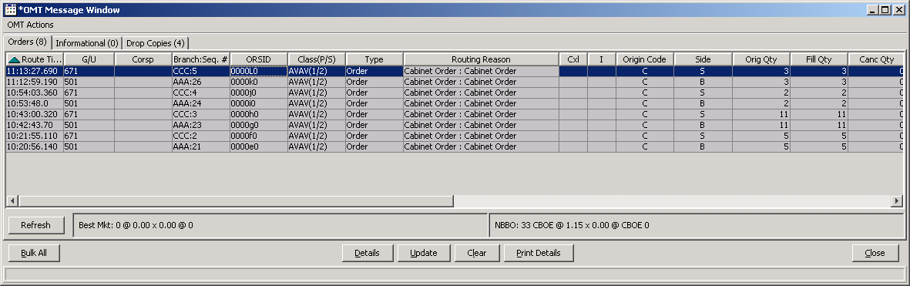

- From the Booth OMT, fill the Market Maker AA’s order with the Contra Broker BB’s order, and fill the Market Maker BB’s order with the Contra Broker AA’s order.
- Select the class for these orders and right-mouse click on the class, and go to the Market History window.
- Verify there is only one sell side the last sale published.

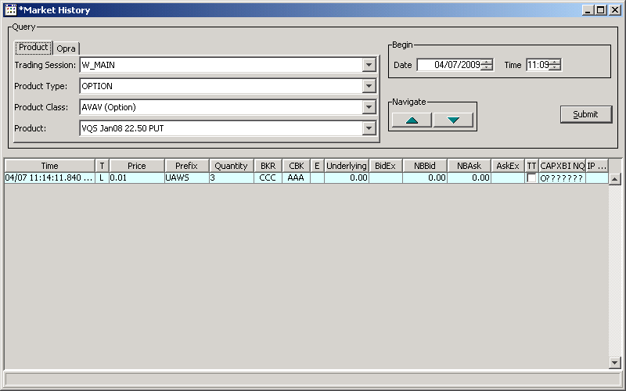

PITS#11341

Test Case 1
- Enter a GTC order and write down the Branch and Branch Sequence Number
- Verify the GTC order is booked
- Cancel the order
- Next day, login to W_MAIN database and run the following query;
SELECT BRANC, BRANCHSEQUENCENUMBER, TIMEINFORCE,
STATE, ORIGINALQUANTITY, TRADEDQUANTITY, CANCELLEDQUANTITY, PURGETIME FROM SBTORDER WHERE
BRANCH = ‘DDD’ and BRANCHSEQUENCENUMBER = XXX;

- Verify the state is 8 (purged) from the above query

PITS#11497
Test Case 1

- Set up Firm Correspondent Class Par to W903 as below;
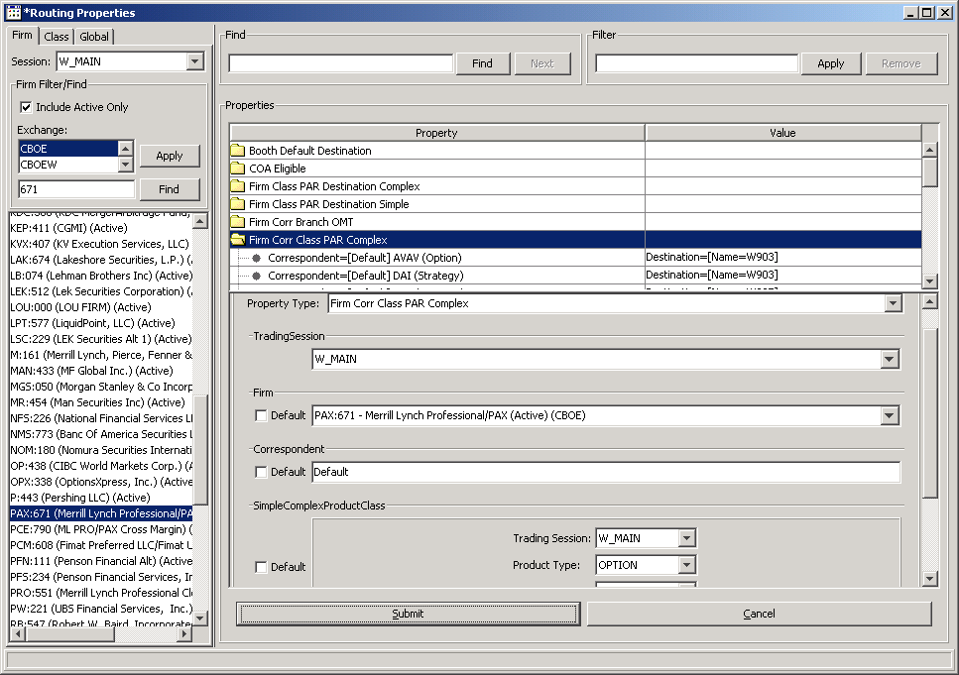
- Log in to W903

  - Create a spread order with contingency type: AON
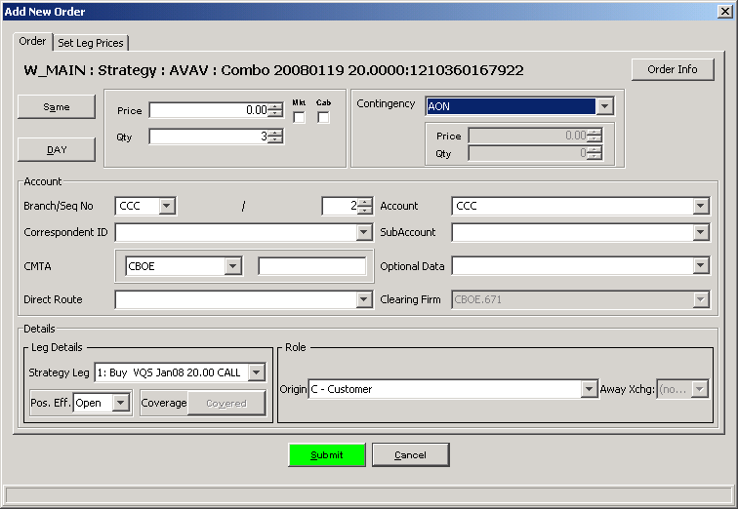

  - Verify the order arrives at the Workstation: W903

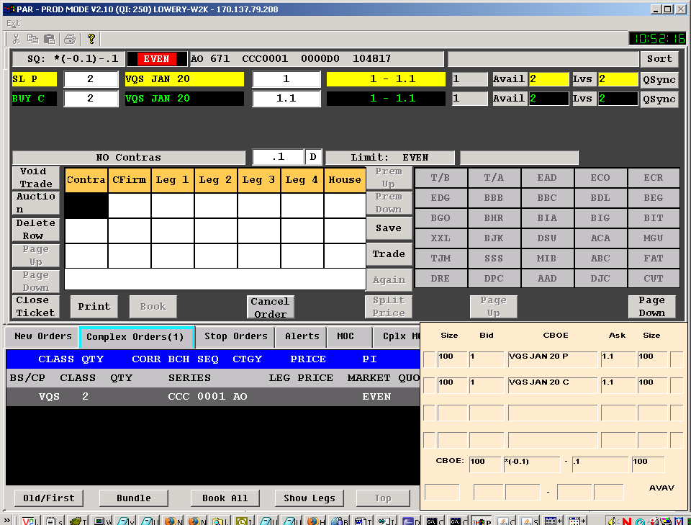

PITS#11581

Test Case 1
- Select a product and enter a GTC order for the product
- Verify the GTC order is booked
- Enter a quote on the product and make sure the order gets filled
- Next day, login to W_MAIN database and runt the following query;

SELECT BRANCH, BRANCHSEQUENCENUMBER, TIMEINFORCE,
STATE, ORIGINALQUANTITY, TRADEDQUANTITY, CANCELLEDQUANTITY, PURGETIME FROM SBTORDER WHERE
BRANCH = ‘DDD’ and BRANCHSEQUENCENUMBER = XXX;
- Verify the GTC order that was FILLED and the column “purgetime” should be empty and state should be 3(Filled)

PITS#11949

Test Case 1
1. Create a spread order and enter a price less than the “tick size meant for that product”, for example the tick is 0.05, but your price is 0.11, 0.12, 0.13 or 0.14.
- You should get a Data Validation Exception as follows;

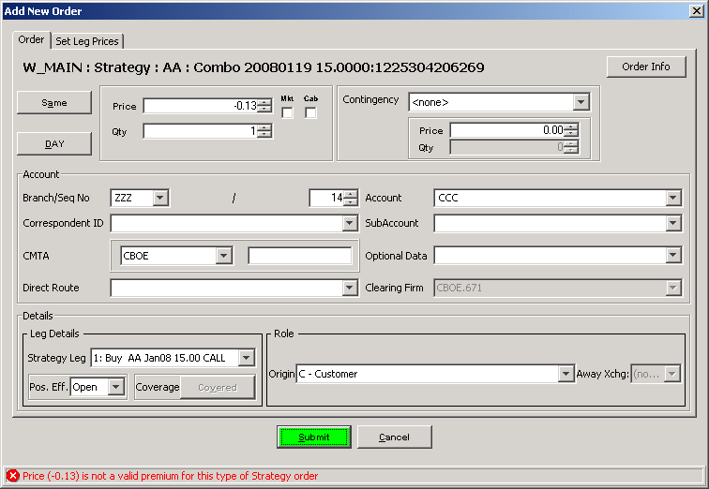

SEDL#7411 – Add new FirmCorrClassPAR via simple/complex via Class/PostStation

Remove the default setting for FirmCorrClassPAR simple/complex routing property;
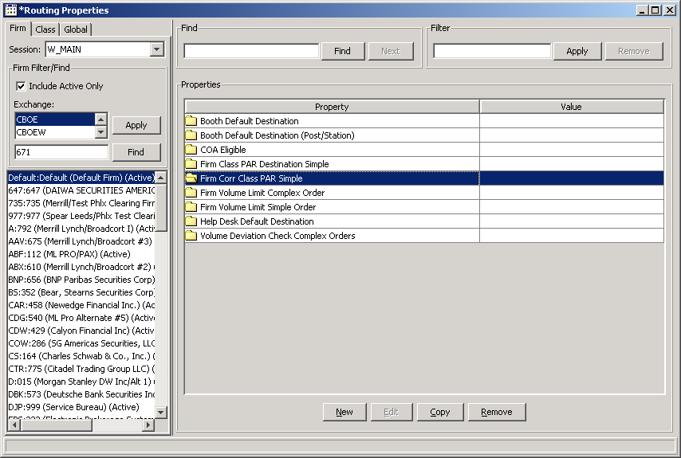

Setup the FirmCorrClassPar routing property as follows;

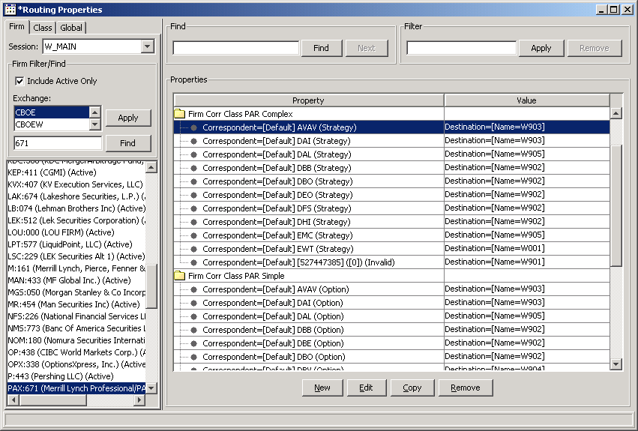

Test Case 1 – FirmCorrClassPAR complex
- Cancel all the quotes for the leg products.
- Create a spread product on these legs, and enter a spread order for the product
- Directly route the order to “crowd”
- Verify your order arriving at Par Workstation W903 below;

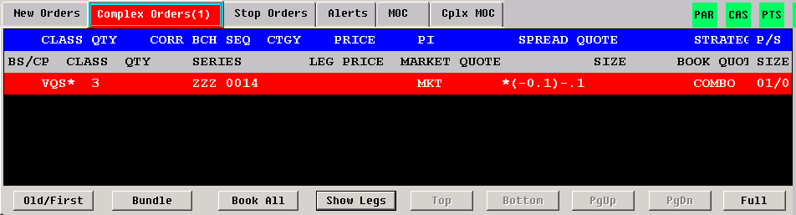

Test Case 2 – FirmCorrClassPAR simple
- Create a simple order and directly route to crowd as follows

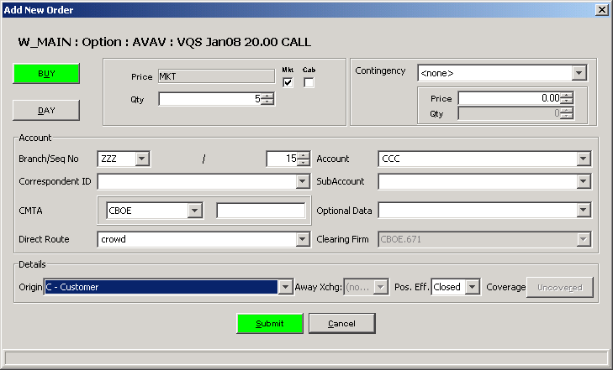

- Verify your order arriving at Par Workstation W903 below
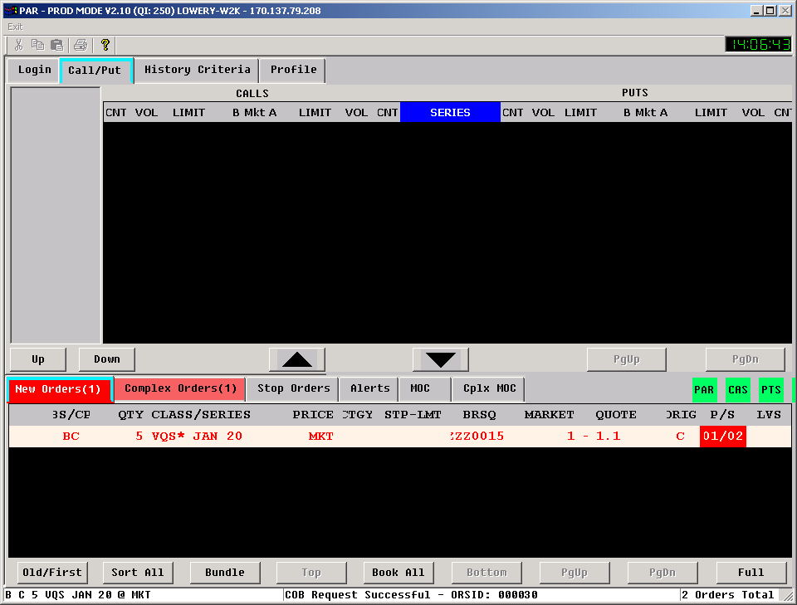

Test Case 3 – FirmCorrClassPAR simple (post/station)

Remove the setting of FirmCorrClassPAR simple routing property for the class, AVAV
Find what are post/station for your class, for example AVAV, add the FirmCorrClassPAR simple post/station as follows:
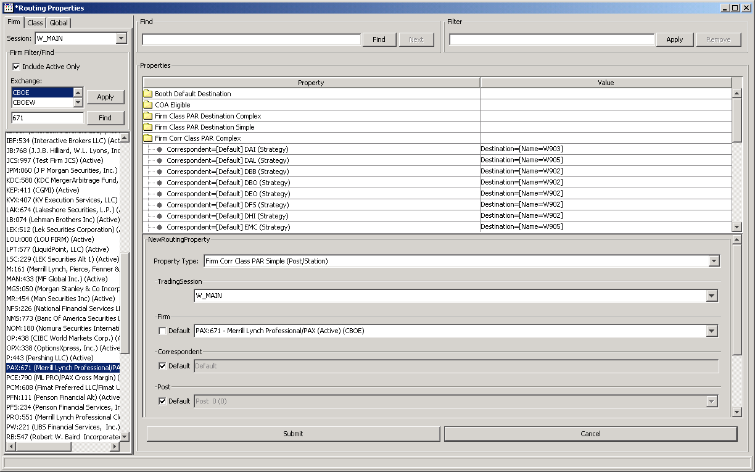

- Make sure there is no default or firm setting for FirmCorrClassPAR simple
- Set the FirmCorrClassPAR simple (post/station) as below, Par Workstation W903 as destination;

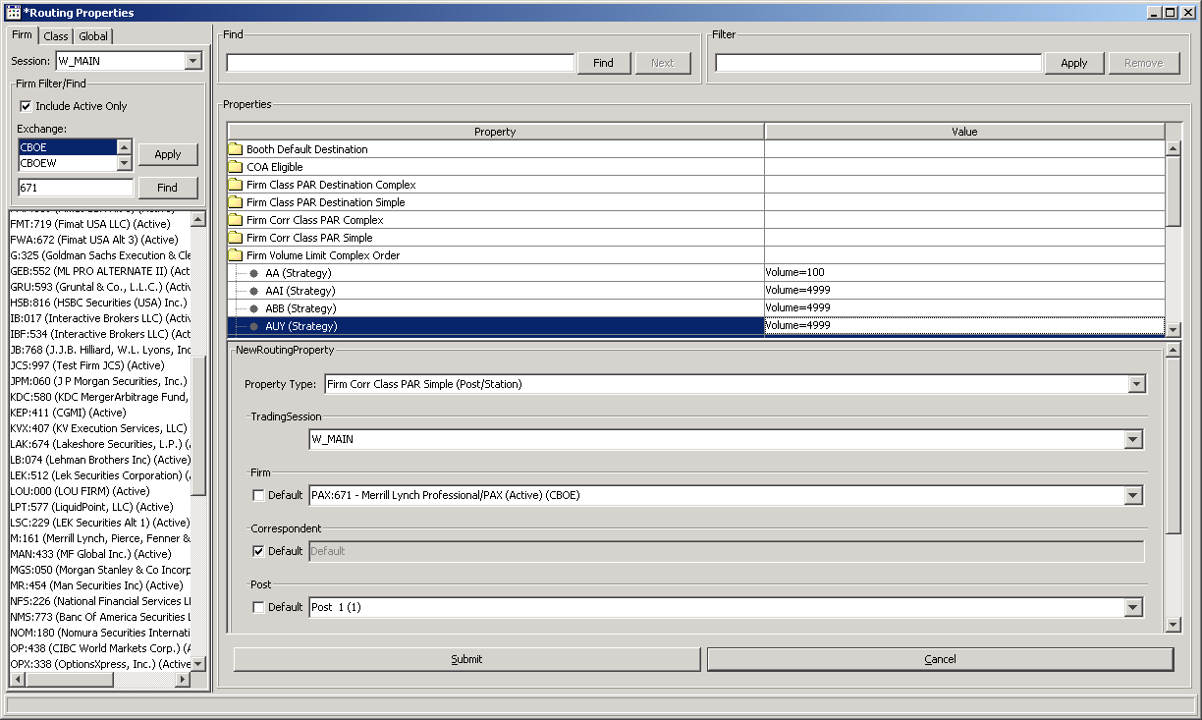
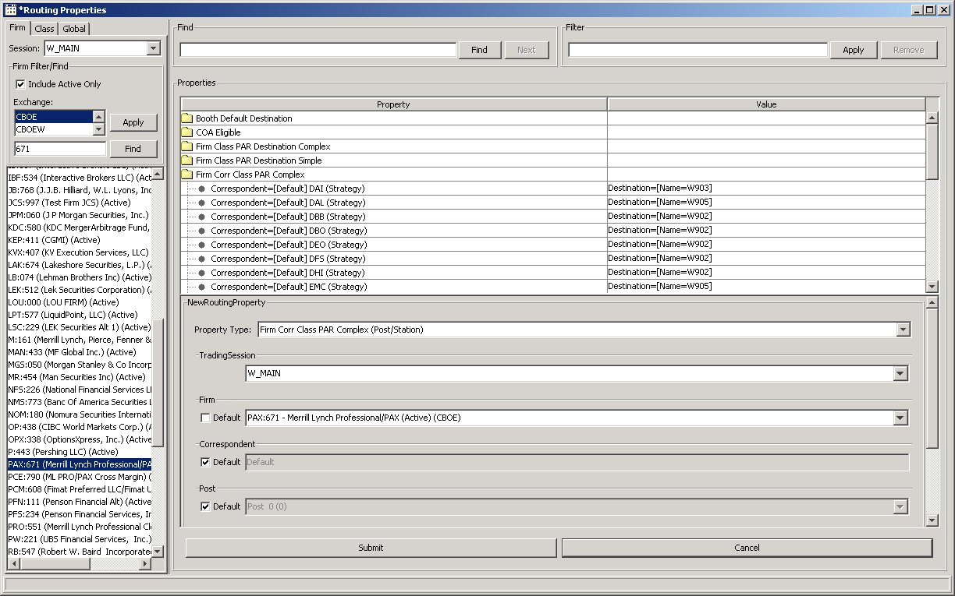

- Create a simple order and directly route to Crowd.
- Verify the order should arrive at the Par Workstation W903 as follows;

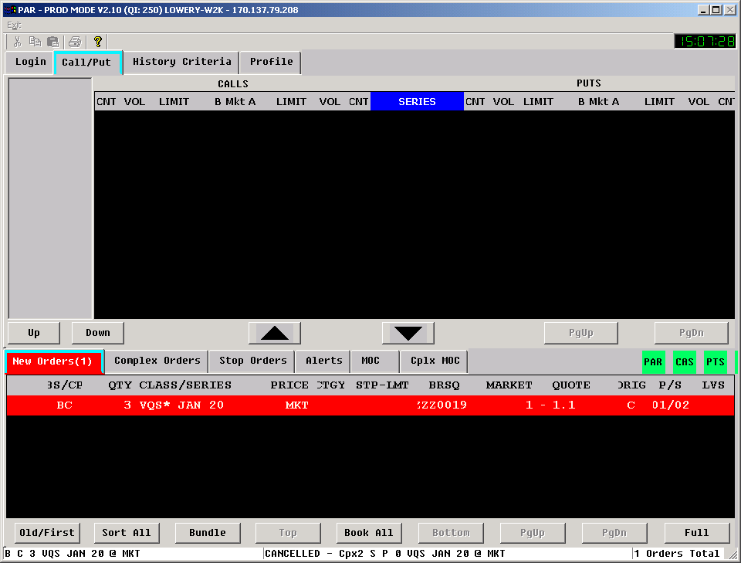

Test Case 4 – FirmCorrClassPAR complex (post/station)
- Remove the setting for the class AVAV on the default FirmCorrClassPAR complex (post/station) below

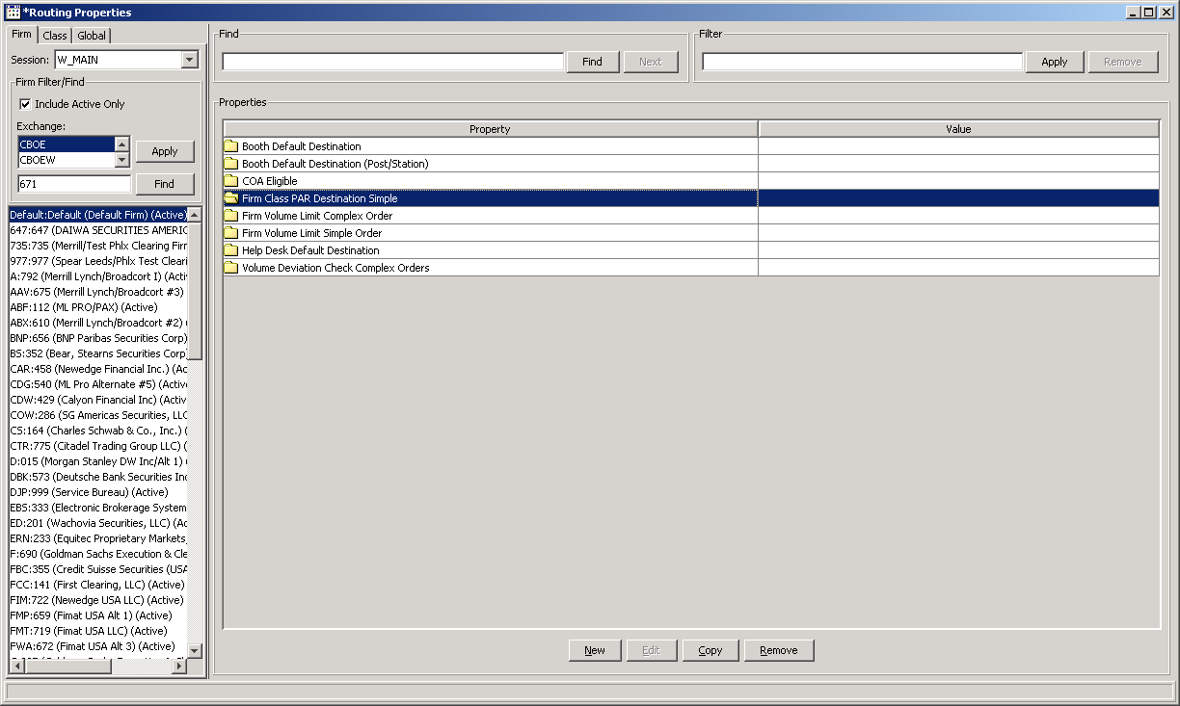

- Remove the setting of FirmCorrClassPAR complex as follows

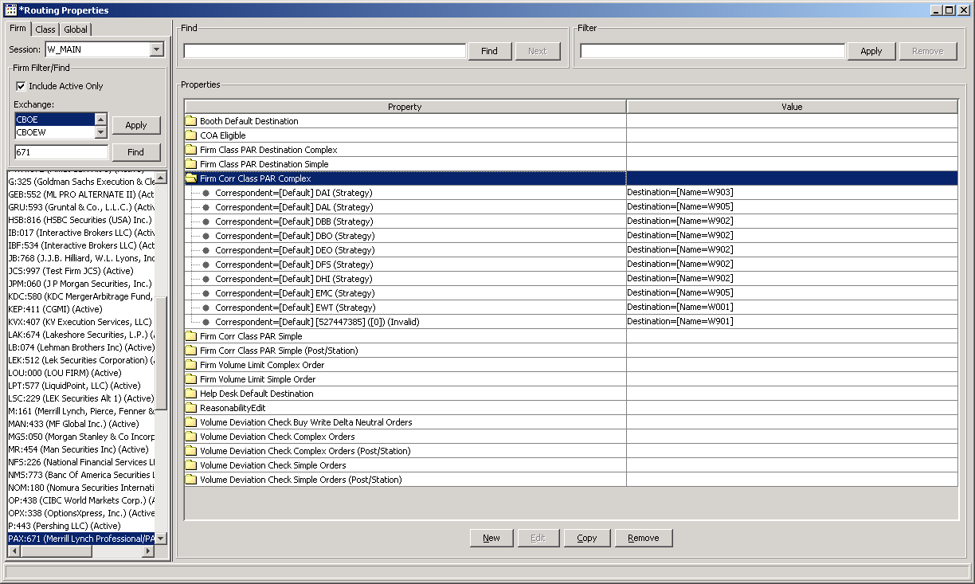

- Add the Setting of FirmCorrClassPAR complex (post/station) as below, post (1), station(2) and destination (W903)

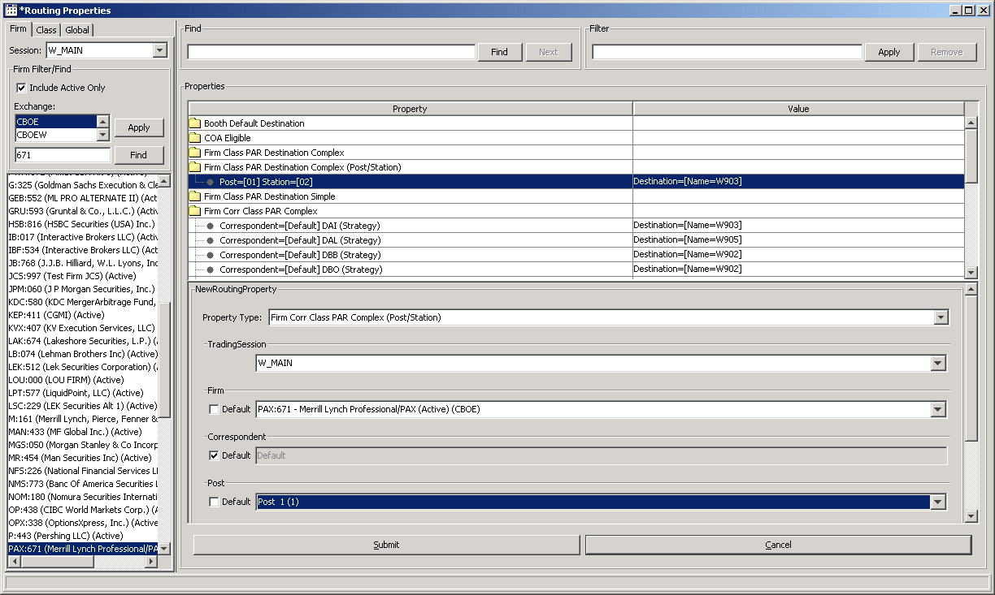

- Create a complex order and directly route to Crowd as follows

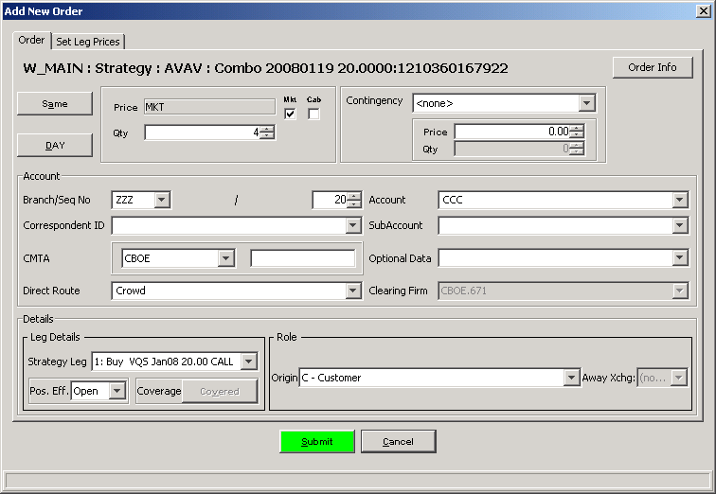

Verify the order arrives the Par Workstation W903 as follows

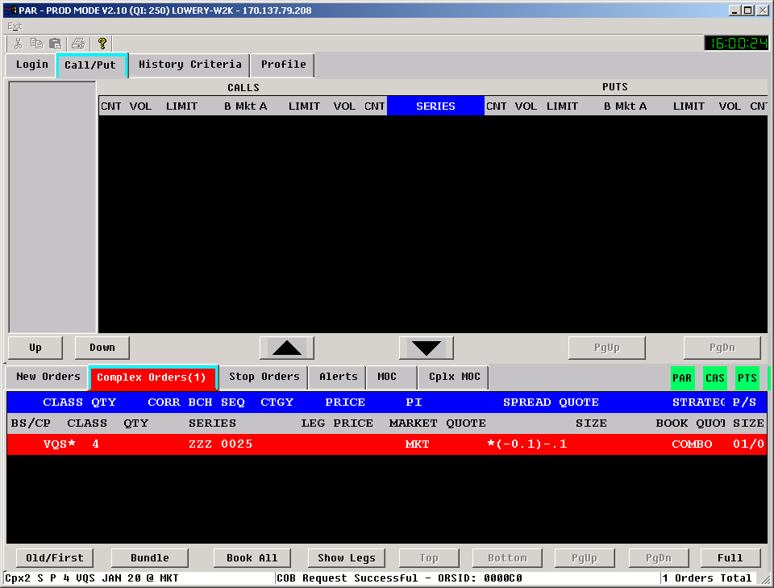

PITS#12494
Test Case 1

- Create a strategy product with ratio 100:19:19
- Enter a Market order with quantity 10 on the strategy product and direct route to Par Workstation W903
- From the W903, partially fill 950:180:180 on the legs

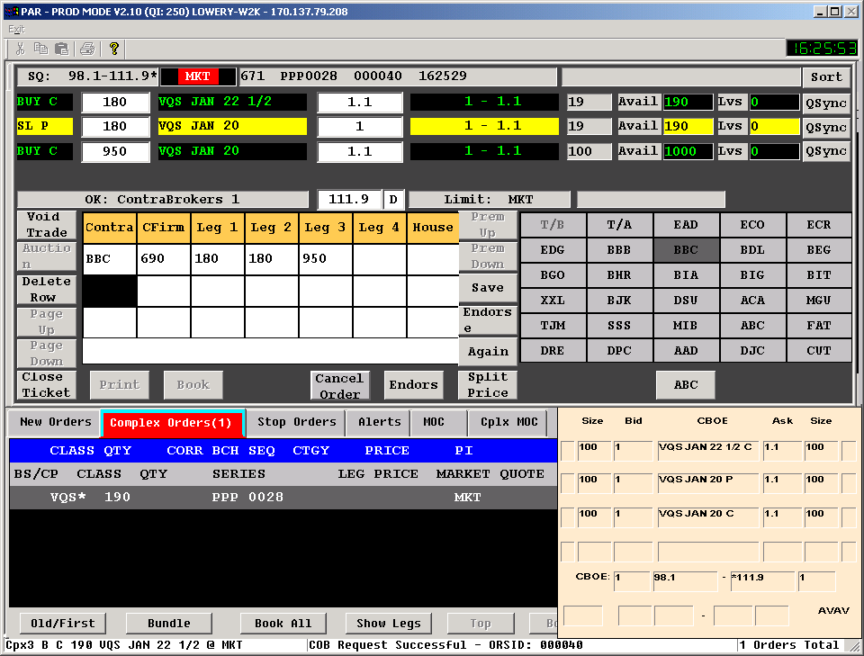

- From the W903, cancel the remaining quantity
- Open the status window from the Trader GUI, verify all the three leg fill reports and a package level fill report and three leg cancel reports and a package level cancel report as follows

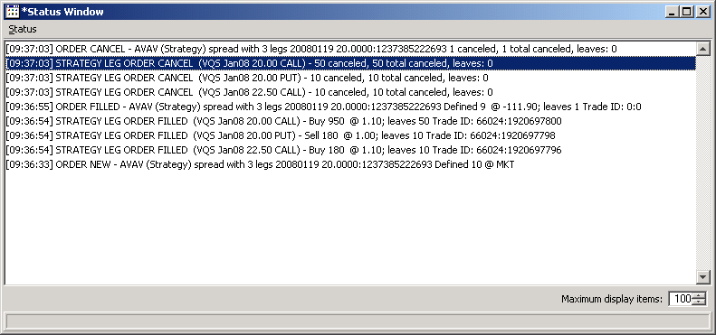

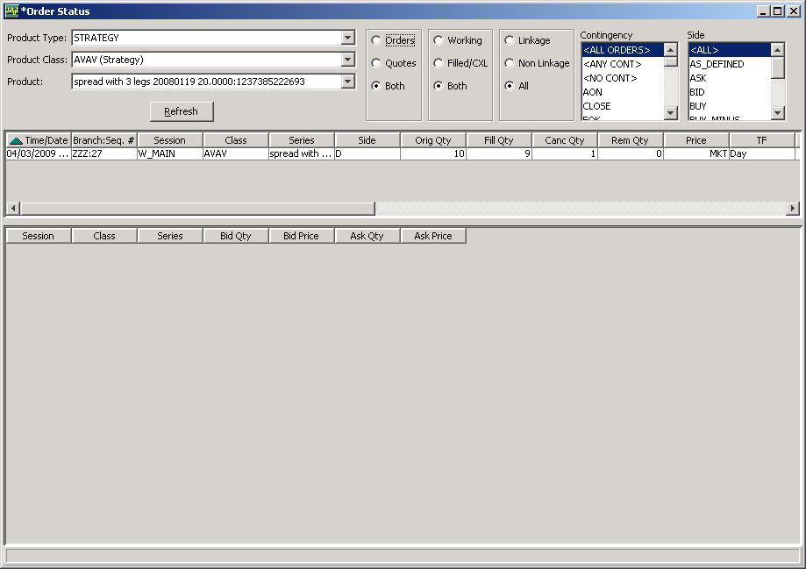

PITS#12532
Test Case 1

Remove all the default setting for Default Booth OMT and FirmCorrBranch OMT(FCB_OMT)
Set the FCB_OMT as follows – destination as B313

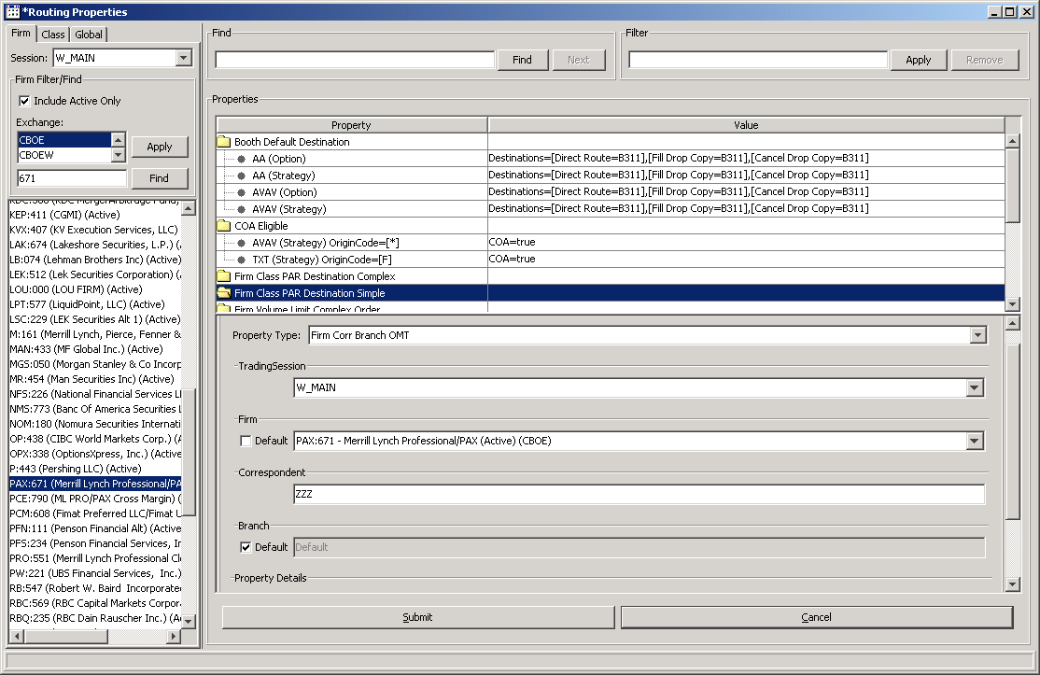

- Log out the Par Workstation W903 and B313
- Enter a simple order and direct route to the W903
- Verify the order is parked at B313 from the order history window as below

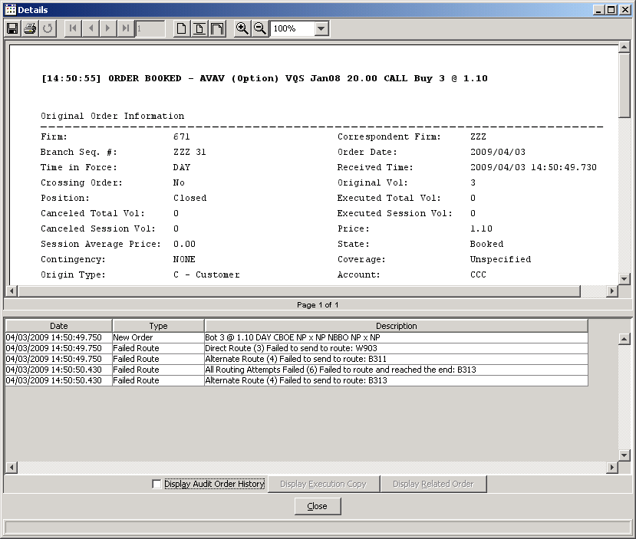

TestPlan_12112

PITS 12112
Check the route description

Route an order to OMT.
Query the order from help desk.
Reroute that order to book
Click on the order details.
You should see the route description as below. (Basically the intent is to differentiate when the owner reroutes the order Vs. the help desk pulls the order out and reroutes it.)

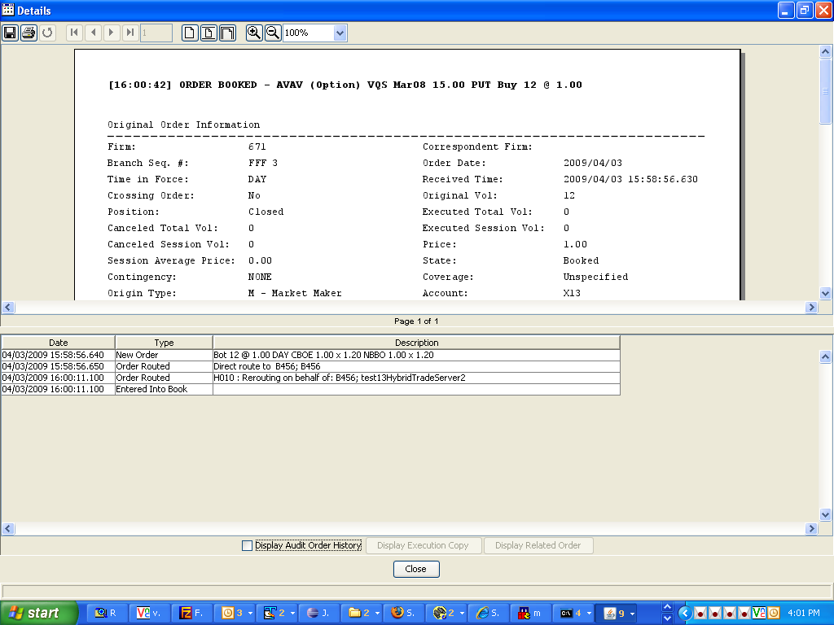

Test Plan

PITS #12047

Route an order without a contingency but with price
For example:
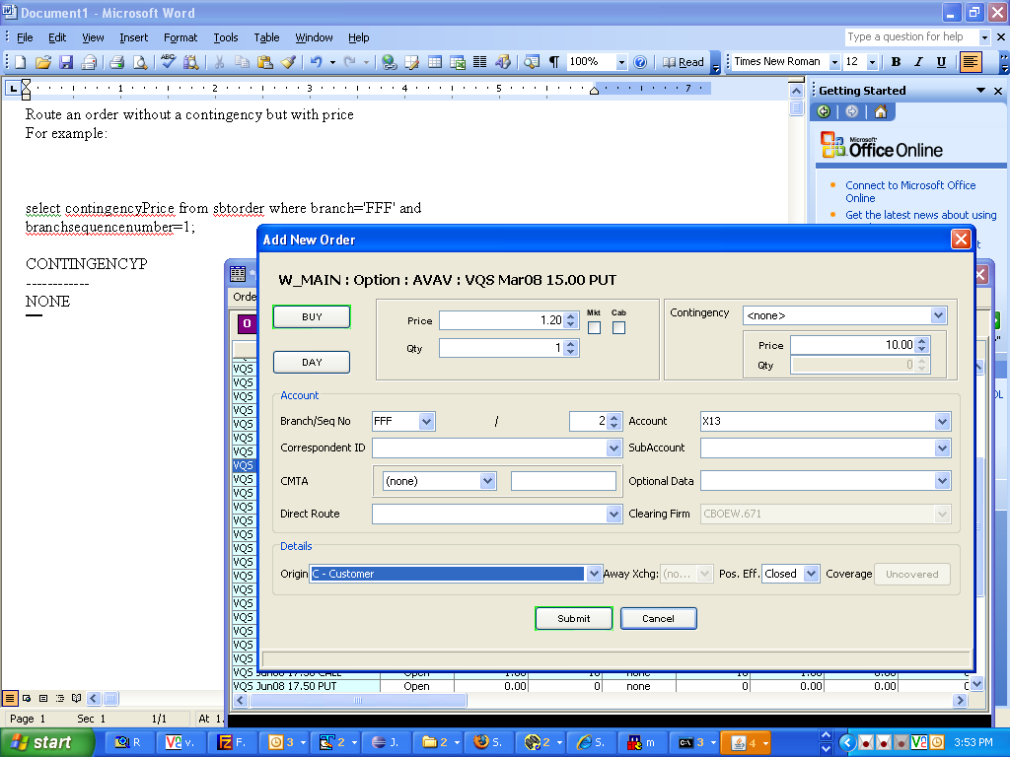

Login to the database:
telnet to the BC you are working on
type: loginDb W_MAIN
at the SQL prompt run the following query.
Replace the branch and branchsequencenumber
select contingencyPrice from sbtorder where branch='FFF' and branchsequencenumber=1;

Enter
The expected result should be:
CONTINGENCYP
------------
NONE

